**Evil portal on ESP Marauder App running most current Unleashed Firmware**

I was running into issues running Evil Portal with the above setup and found a workaround.

1. Shout out to bigbrodude6119 for giving this to us: Go to <https://github.com/bigbrodude6119/flipper-zero-evil-portal>

2.

Click Code and choose download zip:

Go to your Downloads file and choose extract all:

Once extracted go to your downloads file again and choose the extracted folder:



Open the file and open the one and only file:



Then open the Flipper file:

This is the file tree once you open the flipper file:



Double click the above file and you shall see this:



1. Open qflipper and connect flipper.
2. Drag and drop the above folder with the blue arrow into the SD Card/apps_data/marauder folder:

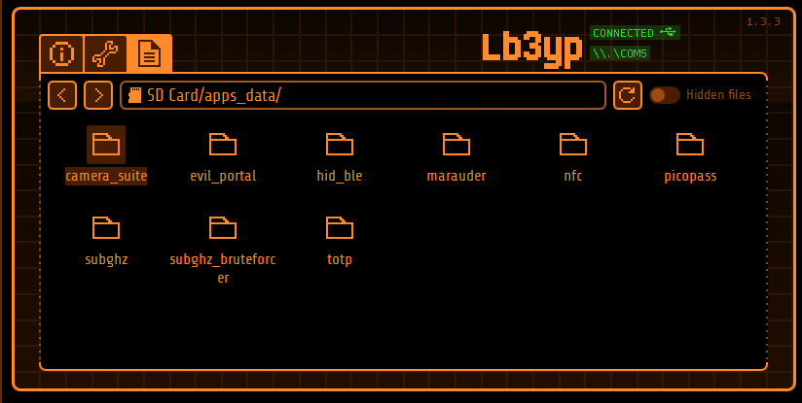

1. Go back to downloads folder and find the portals file:

1. Open the portals file and drag and drop all portals into the evil_portal file on the flipper:

1. This is your path on your flipper with html docs:

1. Now go to apps:

GPIO

[ESP32]WiFi Marauder:

SSID and add a name for SSID:

Add Name of SSID and save:

Go back out to List and choose ssid:

Find the number of the ssid you want to use:

Back out and go to Select ssid:

Now enter the number of the ssid you want to use and be sure to save:

Now go to Load Evil Portal HTML file:

Open evil_portal file:

Choose HTML you want to use:

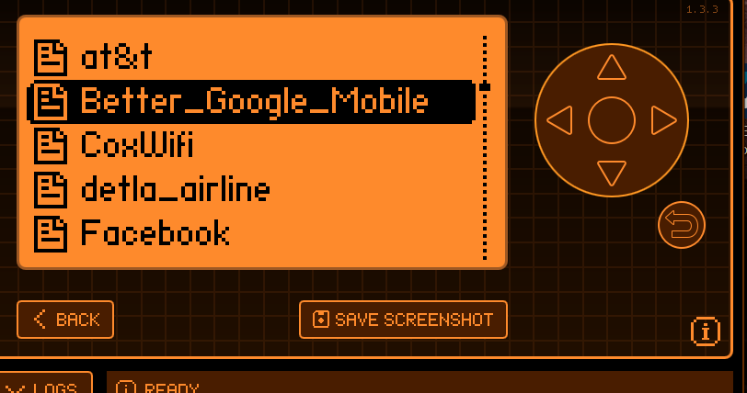

This is what you should see:

Go back out to Evil Portal “start”:

Hit the button and should be up and running:

1. Now that your portal is running you can go to your wifi access points on your phone or computer and try to connect with the wifi ssid that you created and it should take you to the IP address of your portal.

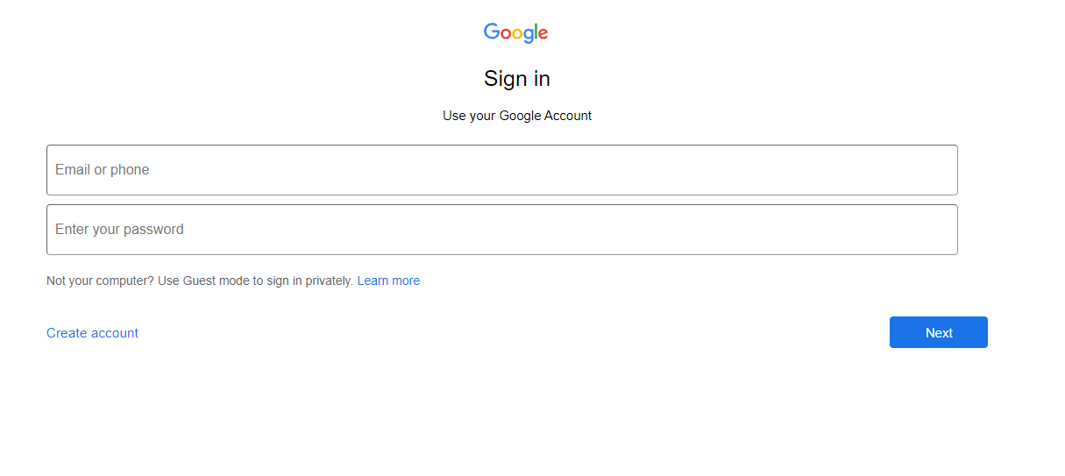

1. Enter anything in the Username and Password sections and hit next:

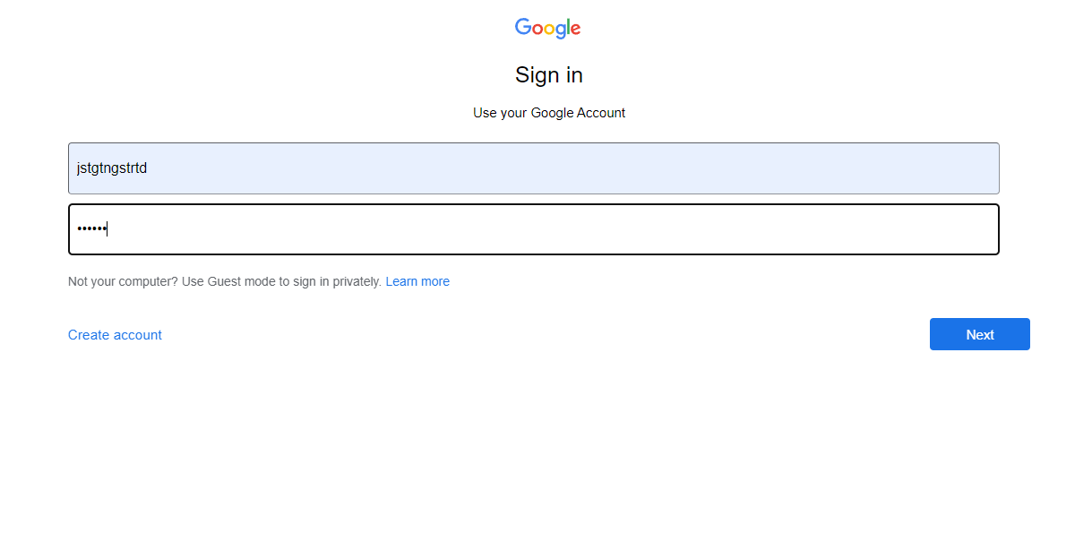

1. After you hit next on the web browser the username and password should appear on the flipper:

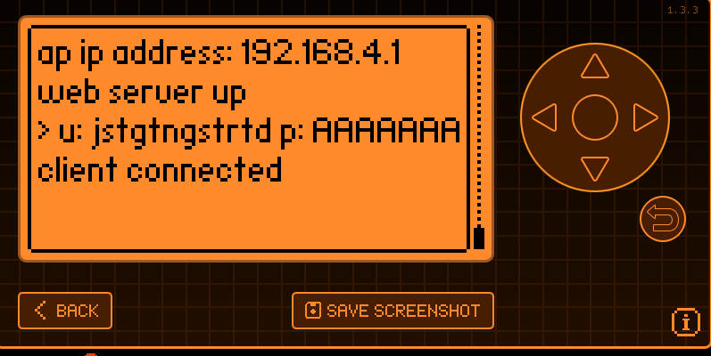

This is for educational purposes only. Much love to the devs creating this stuff!!